ATTACHMENT 6: Maps
Map 1: Existing Land Reservation Map in relation to 46 Fairmount St, Lakemba

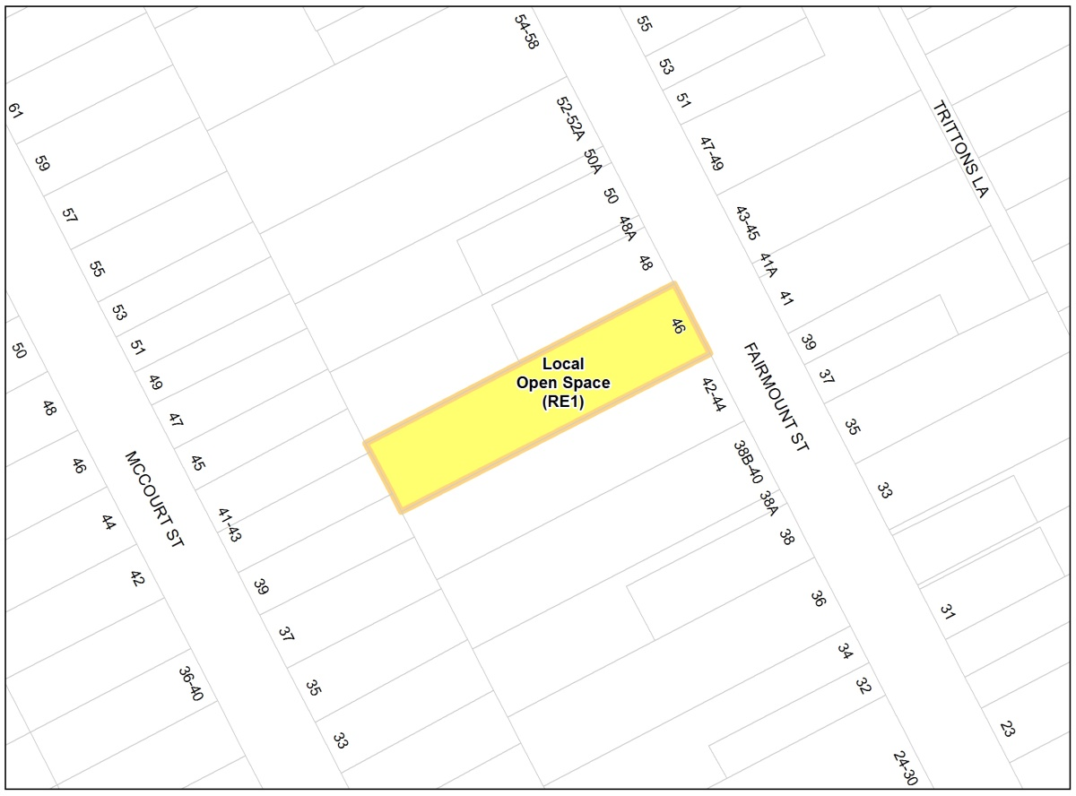

Map 2: Proposed Land Reservation Map in relation to 46 Fairmount St, Lakemba

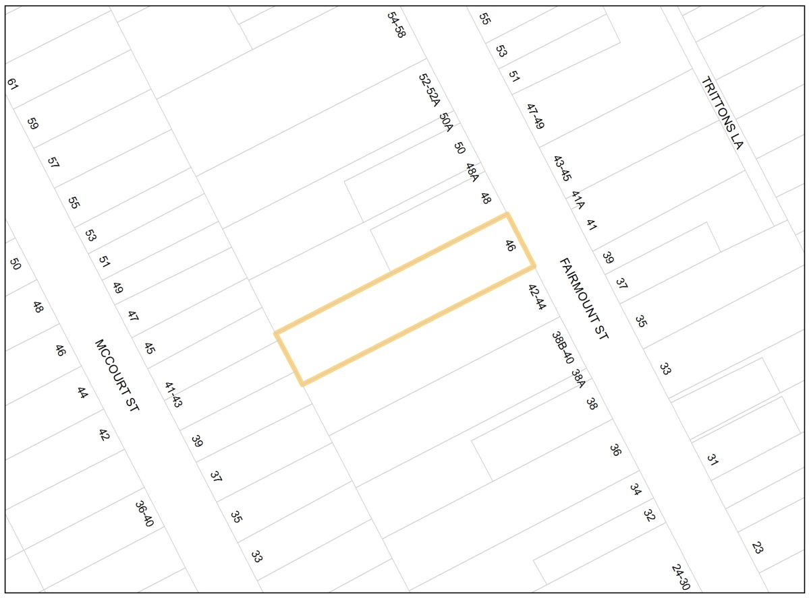

Map 3: Existing Land Reservation Map in relation to 15 Wangee Rd, Lakemba

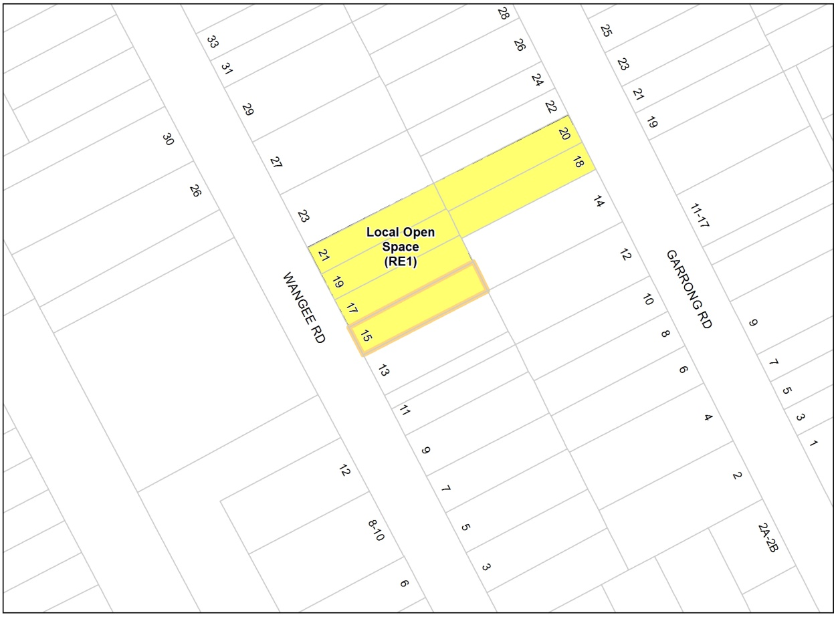

Map 4: Proposed Land Reservation Map in relation to 15 Wangee Rd, Lakemba

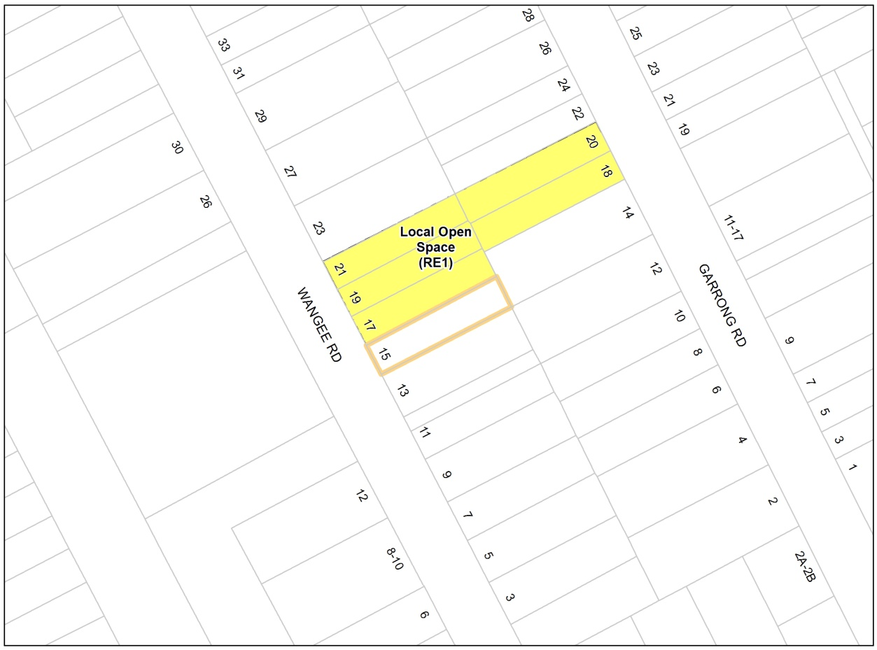

Map 5: Existing Land Reservation Map in relation to 39 Ludgate St, Roselands

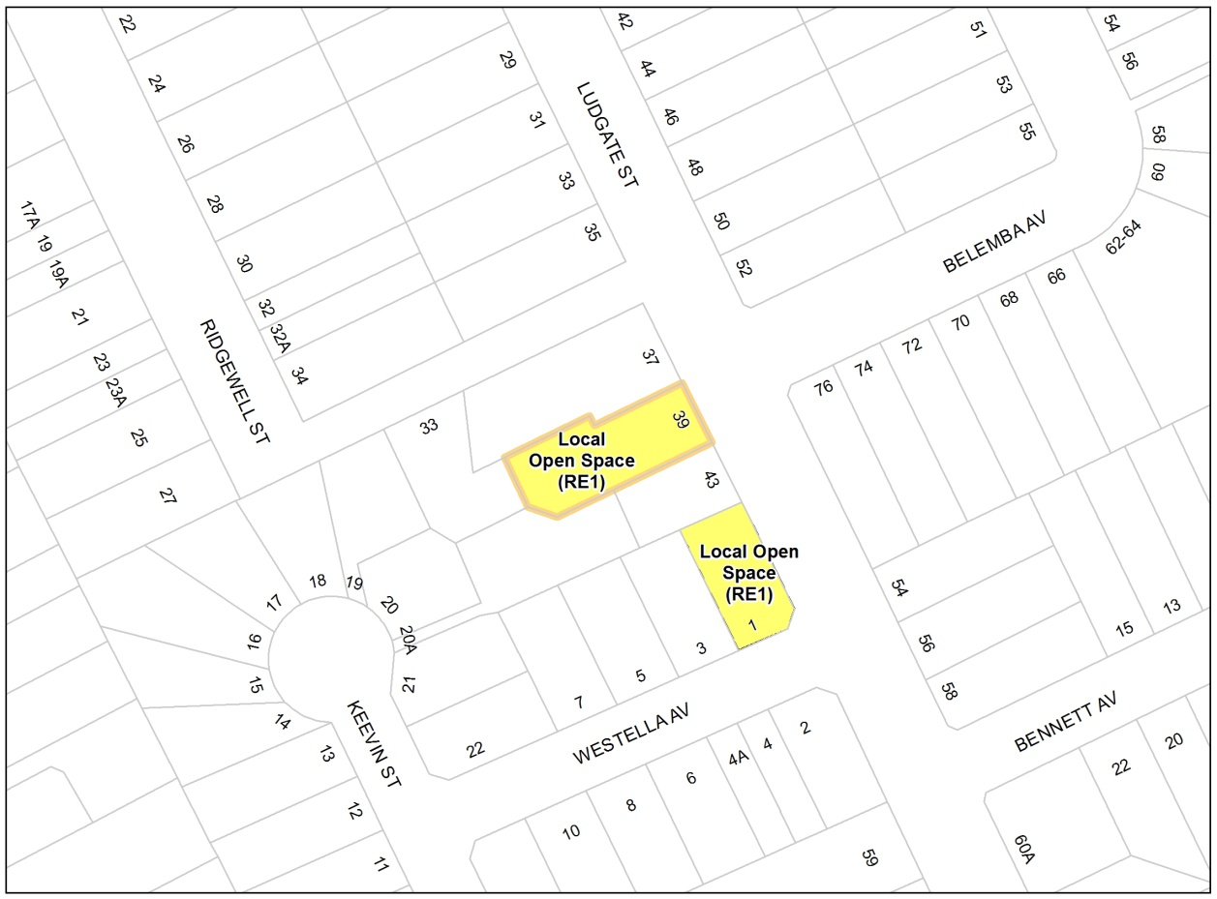

Map 6: Proposed Land Reservation Map in relation to 39 Ludgate St, Roselands

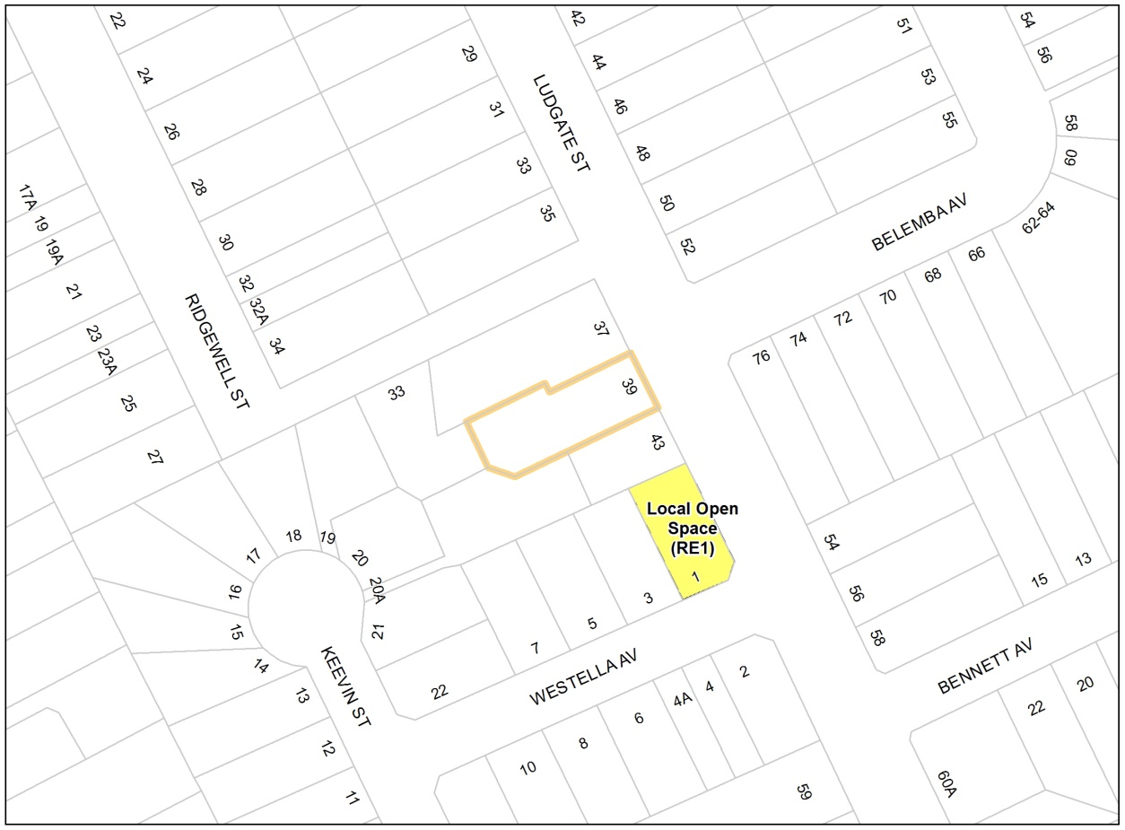

Map 7: Existing Land Reservation Map in relation to 34 Allan Av, Belmore

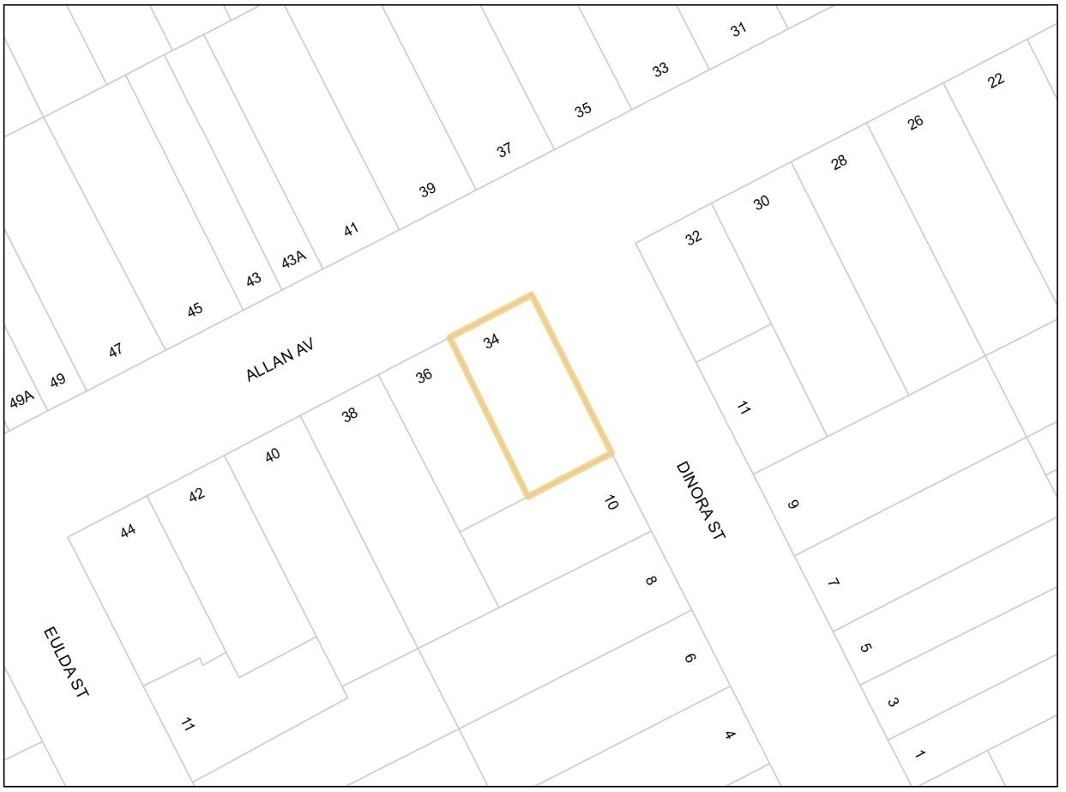

Map 8: Proposed Land Reservation Map in relation to 34 Allan Av, Belmore

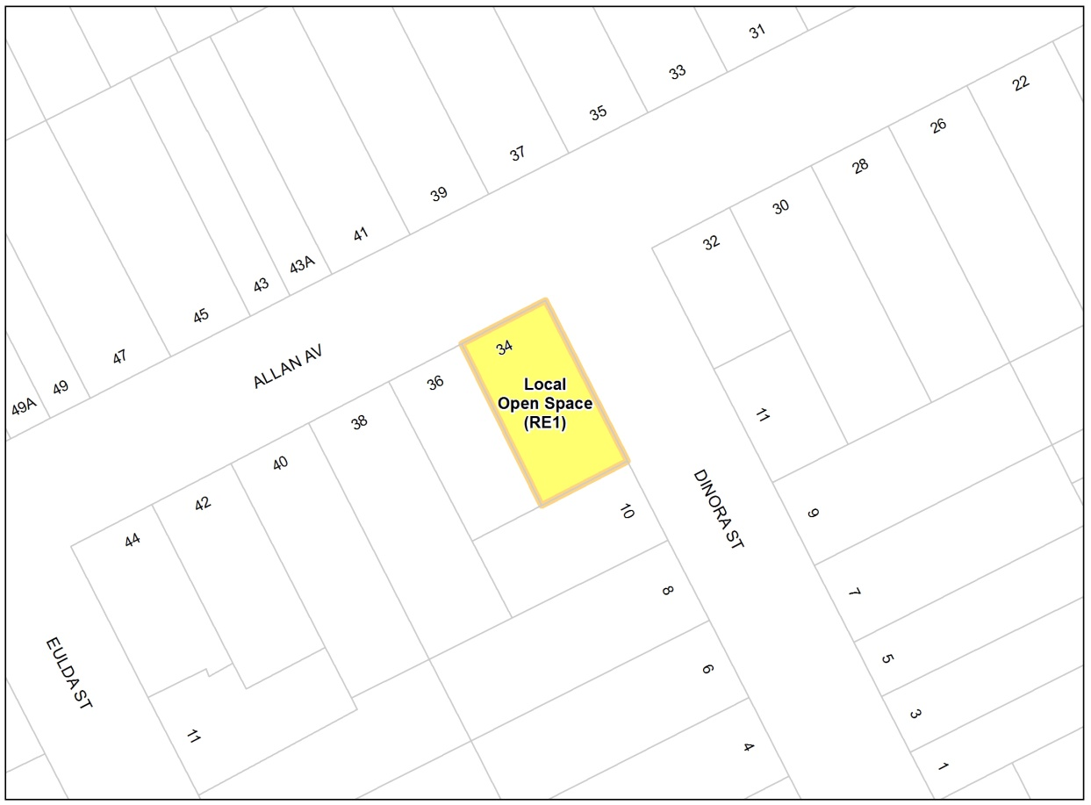

Map 9: Existing Land Zoning Map in relation to 102-102A Rogers St, Roselands

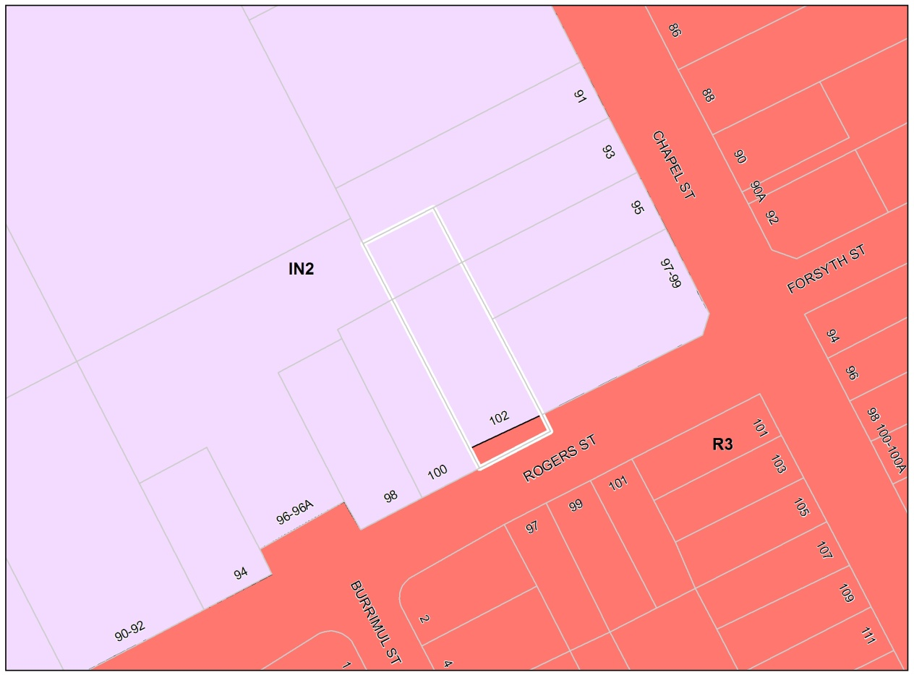

Map 10: Proposed Land Zoning Map in relation to 102-102A Rogers St, Roselands

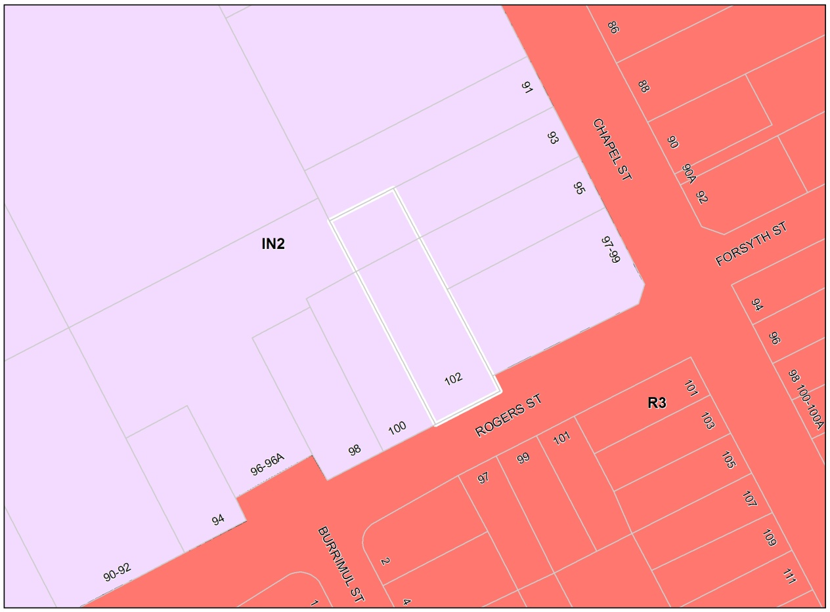

Map 11: Existing Height of Building Map in relation to 102-102A Rogers St, Roselands

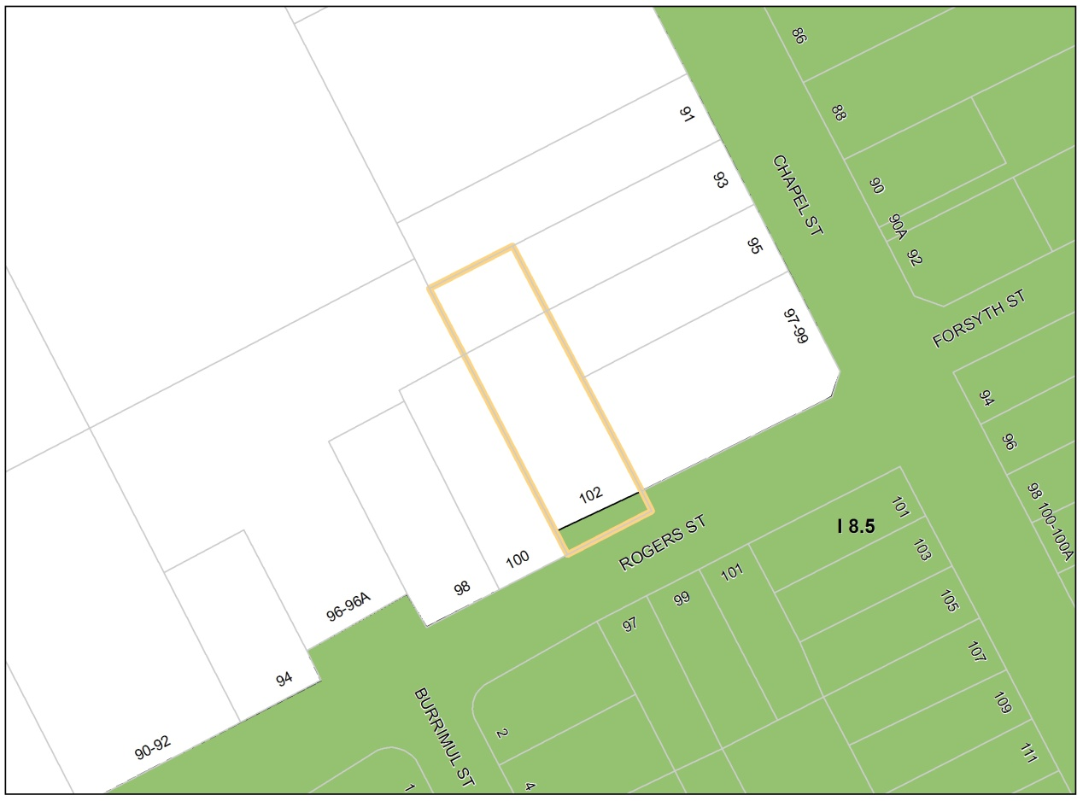

Map 12: Proposed Height of Building Map in relation to 102-102A Rogers St, Roselands

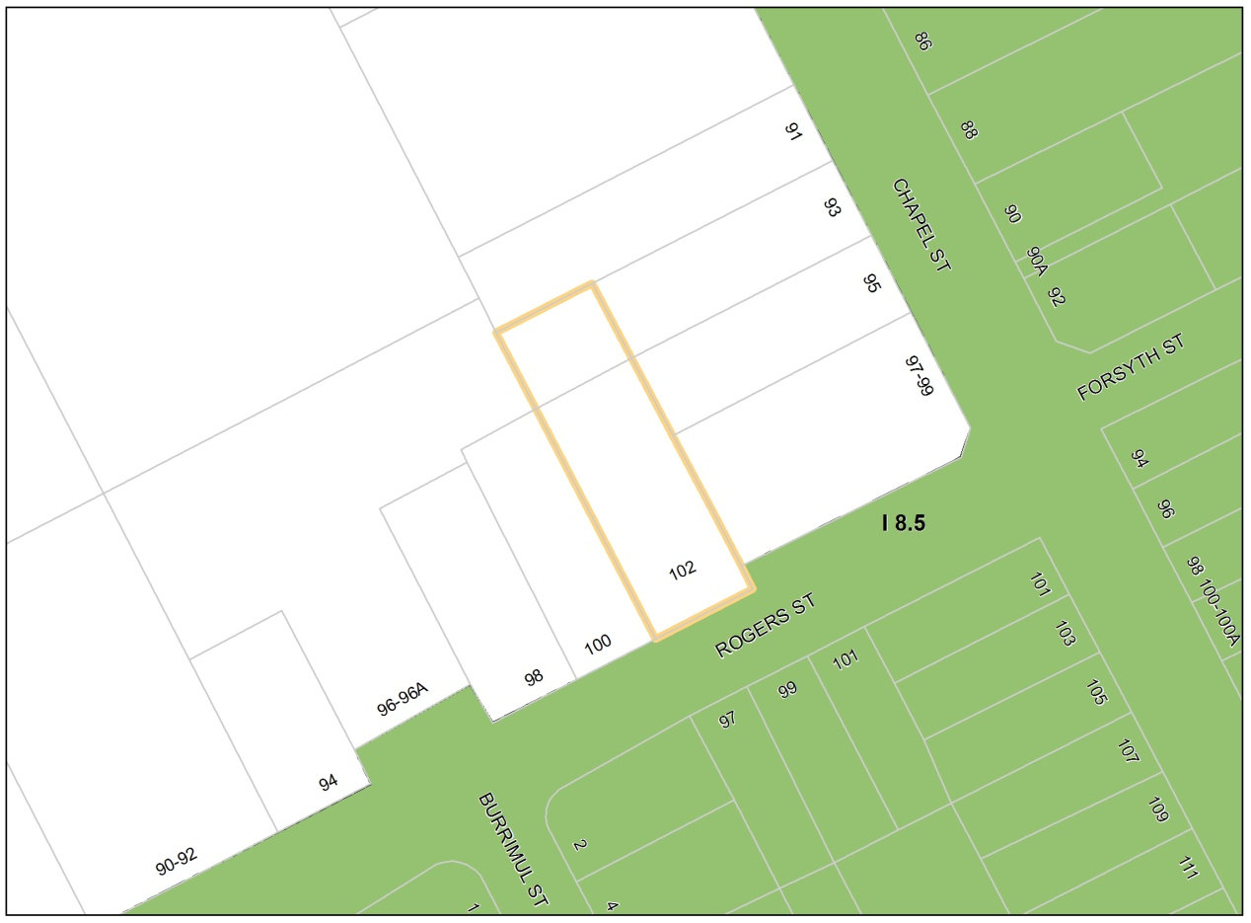

Map 13: Existing Floor Space Ratio Map in relation to 102-102A Rogers St, Roselands

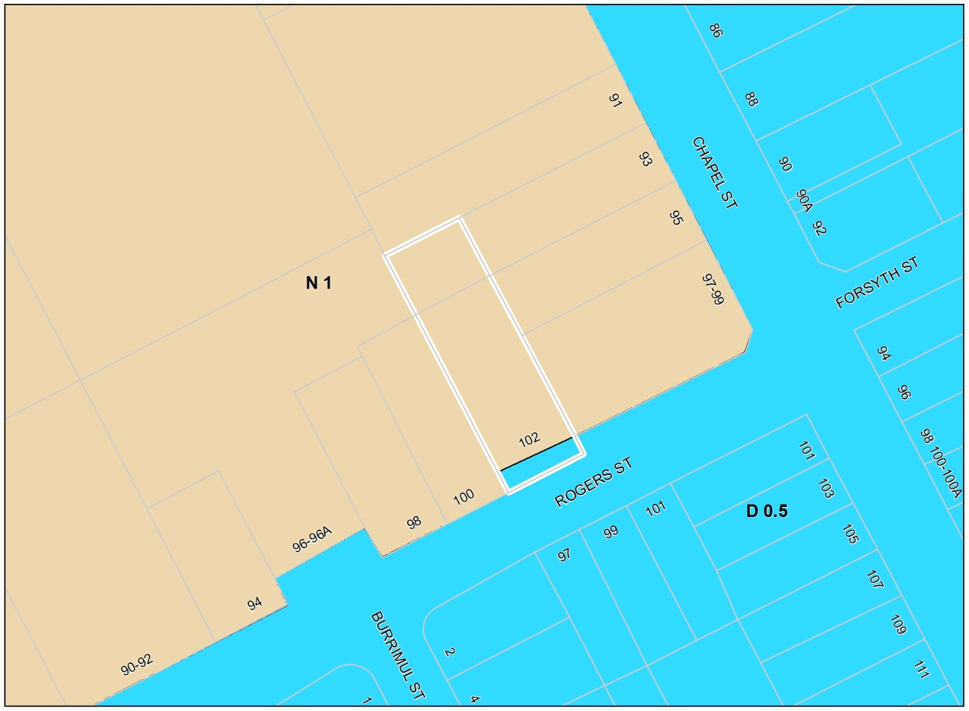

Map 14: Proposed Floor Space Ratio Map in relation to 102-102A Rogers St, Roselands

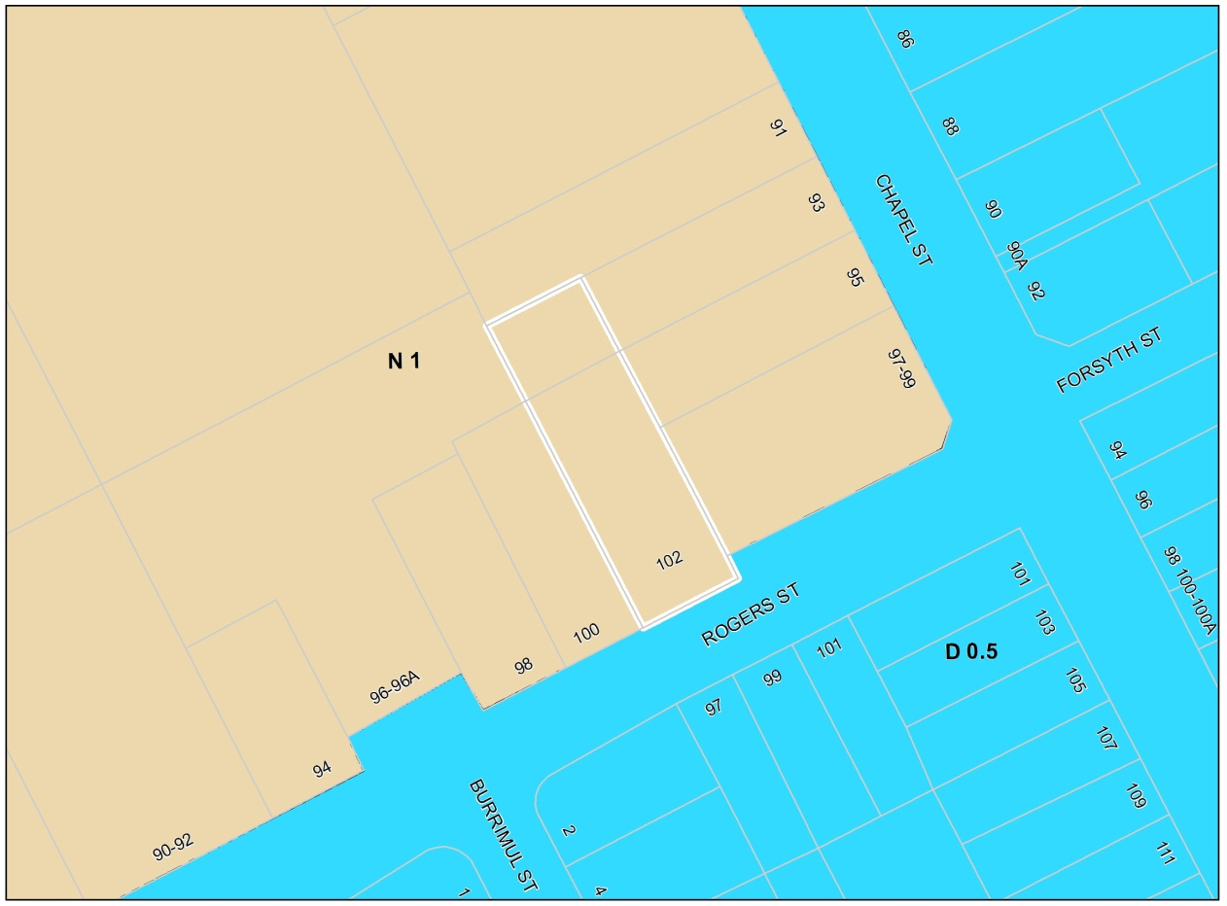

Map 15: Existing Land Zoning Map in relation to 3 Sunbeam St and 60 Charlotte St, Campsie

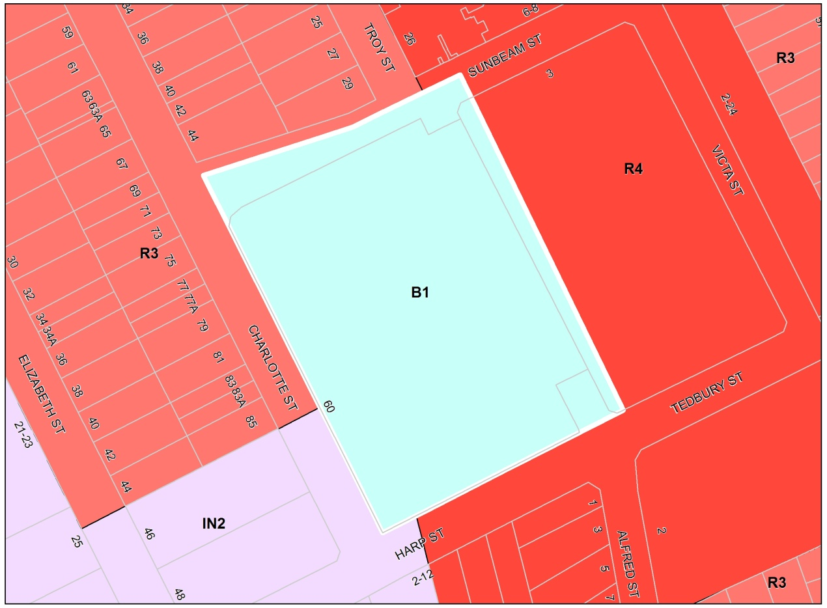

Map 16: Proposed Land Zoning Map in relation to 3 Sunbeam St and 60 Charlotte St, Campsie

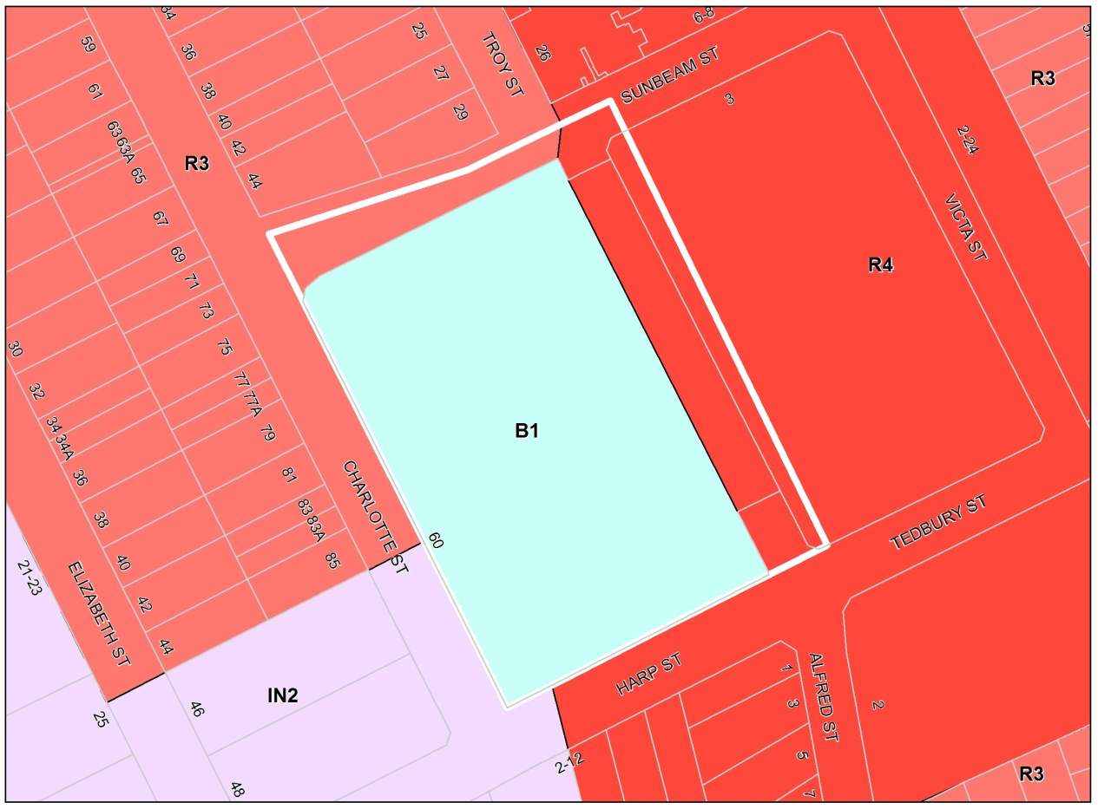

Map 17: Existing Height of Building Map in relation to 3 Sunbeam St and 60 Charlotte St, Campsie

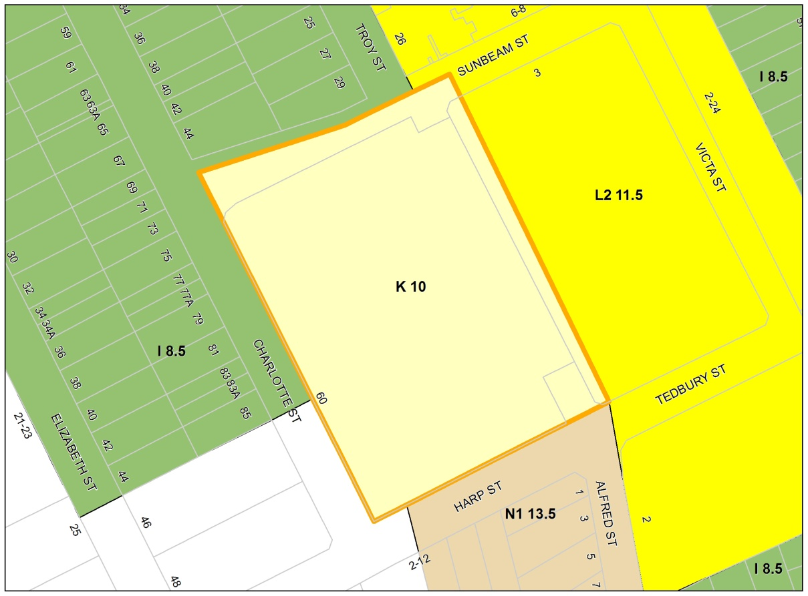

Map 18: Proposed Height of Building Map in relation to 3 Sunbeam St and 60 Charlotte St, Campsie

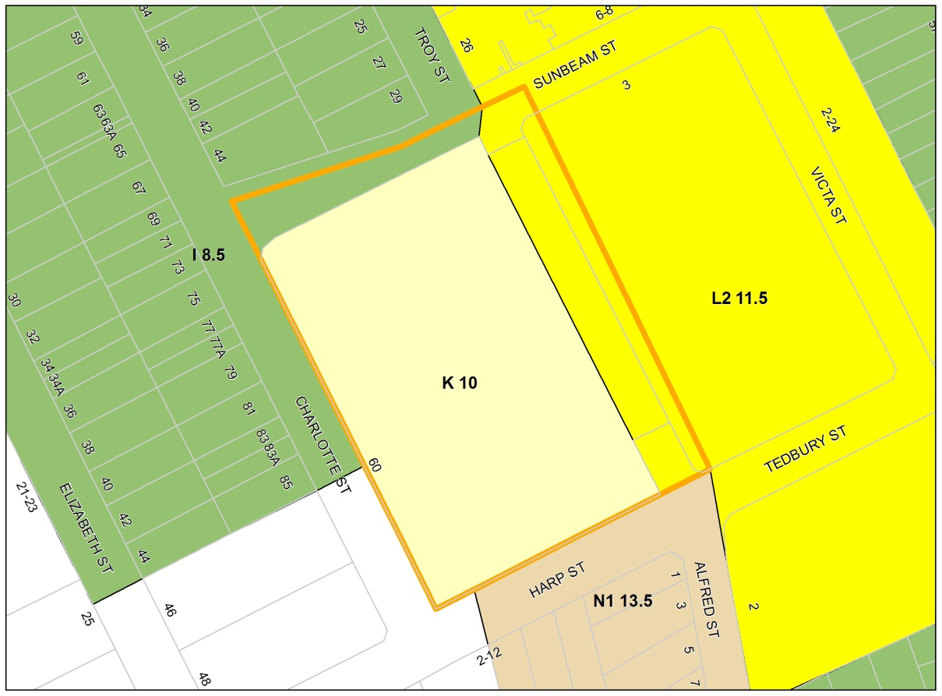
Map 19: Existing Floor Space Ratio Map in relation to 3 Sunbeam St and 60 Charlotte St, Campsie

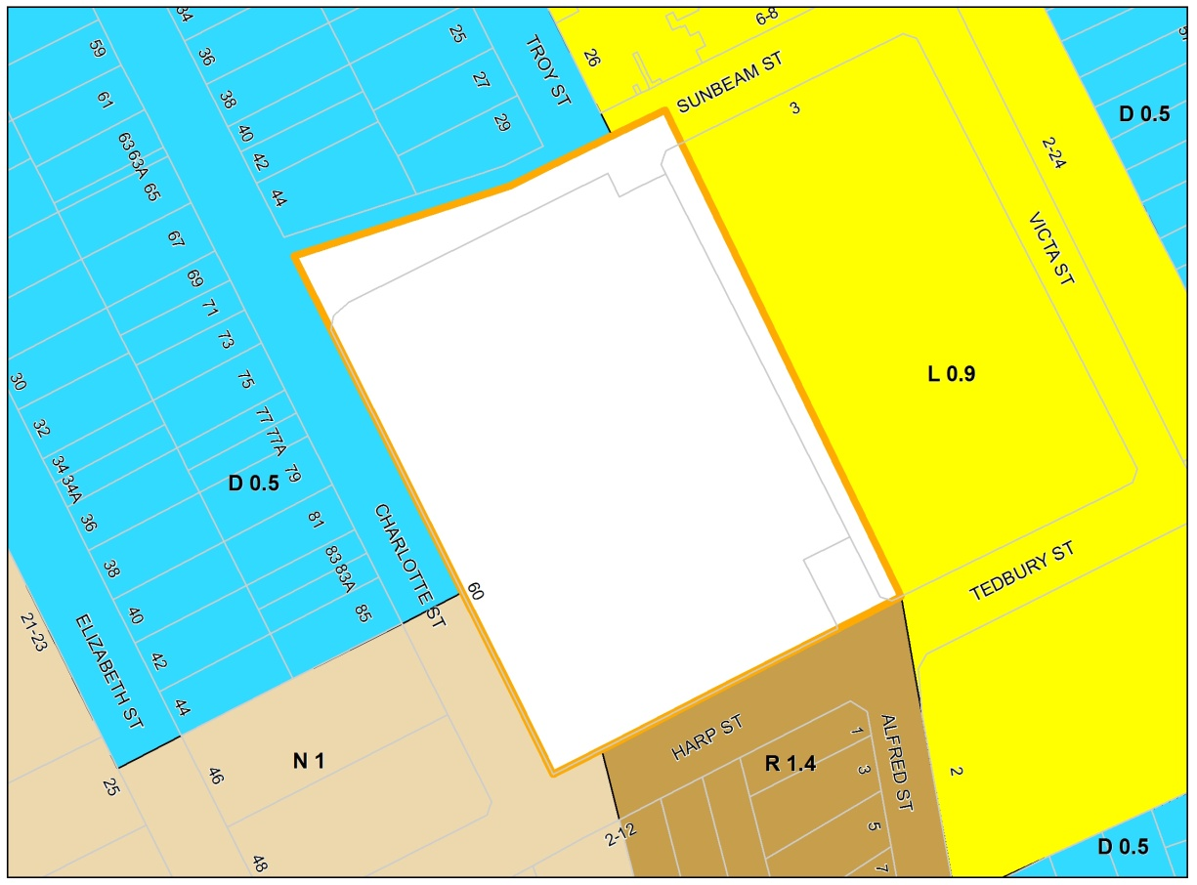

Map 20: Proposed Floor Space Ratio Map in relation to 3 Sunbeam St and 60 Charlotte St, Campsie
