Public Exhibition of Planning Proposal – Housekeeping amendments to Canterbury LEP 2012

Planning Proposal
PP_2016_CANTE_001_00

Various amendments to correct mapping anomalies, typographical errors, LEP text and schedule 5 – Environmental Heritage.

June 2017
Table of Contents

 | Executive Summary |  | 3
1 | Land Description and Characteristics |  | 4
2 | Objectives or intended outcomes |  | 12
3 | Explanations of Provisions – Proposed Amendment |  | 13
4 | Justification |  | 16
5 | Mapping |  | 21
6 | Community Consultation |  | 21
7 | Project Timeline |  | 21
ATTACHMENTS
1 | Information Checklist
2 | State Environmental Planning Policies
3 | Section 117 Directions
4 | Evaluation Criteria for the Delegation of Plan Making Functions
5 | Delegated plan for making reporting template
6 | Maps
7 | Council Resolution 12 November 2015

Executive Summary

The Canterbury Local Environmental Plan 2012 was published in the Government Gazette on 21 December 2012 and become operational from January 2013. Since that date, a number of minor discrepancies, errors and other matters have been identified that require amendment or correction via the preparation of a Planning Proposal.

These matters primarily relate to the correction of a number of minor mapping anomalies and/or typographical errors, some minor corrections to the LEP text and the Heritage Register Schedule. The purpose of this Planning Proposal is to rectify these matters requiring amendment, correction or adjustment.

Council on 12 November 2015 considered a report regarding these anomalies and minor errors and resolved to amend Canterbury Local Environmental Plan 2012 via the preparation of a Planning Proposal. The matters that require rectification are:

- Amendments to the Planning Instrument,
- Amendments to the Heritage Schedule, and
- Amendments to various LEP’s Maps.

The planning proposal has been prepared in accordance with Section 55 of the Environmental Planning and Assessment Act 1979 and the Department of Planning and Infrastructure’s “A guide to preparing planning proposals”.

A Gateway Determination under Section 56 of the Act is requested.

- Land Description and Characteristics

The Planning Proposal applies to various parcels of land within the Canterbury Council area, which are described in more details in table below:

Table 1 – Property Description and Current Land Use
Address | Property Description | Current Land Use
46 Fairmount Street, Lakemba | Lot 49 in DP6351 | Open Space
15 Wangee Road, Lakemba | Lot D in DP 312230 | Dwelling House
39 Ludgate Street, Roselands | Lot 4 in DP701311 | Dwelling House
34 Allan Avenue, Belmore | Lot B in DP355867 | Dwelling House
102-102A Rogers Street, Roselands | Lot 1 in DP 623244, and  Lot B in DP 399441 | Industrial, warehouse like building
3 Sunbeam Street, Campsie | Lot 3 in SP89762 | Residential apartments buildings
60 Charlotte Street, Campsie | Lot 32 in DP1185029 | Construction site

The sites subject to this Planning Proposal have been previously developed for many years and adequate services capacities have been provided. Consequently, the land use pattern will remain predominantly unchanged as a result of this Planning Proposal.
Existing and proposed map amendments are shown at Attachment 6 Maps.

46 Fairmount Street, Lakemba

This parcel of land at 46 Fairmount Street, Lakemba is shown on the Land Reservation Acquisition Map (Map 1), as Local Open Space (RE1). Council is the responsible acquisition authority and has recently completed acquisition of this land for public recreation purposes. Consequently, no longer needs to be shown on the Land Acquisition Map (Map 2).

The aerial photo showing locality of 46 Fairmount Street, Lakemba

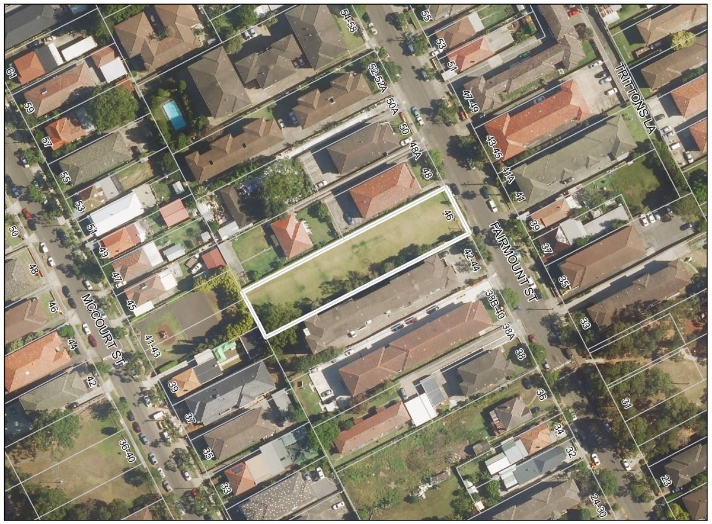

15 Wangee Road, Lakemba

This parcel of land at 15 Wangee Road, Lakemba is also shown on the Land Reservation Acquisition Map (Map 3), as Local Open Space. Council has recently completed acquisition of this land for public recreation purposes and as such it no longer needs to be shown on the Land Acquisition Map (Map 4).

The aerial photo showing locality of 15 Wangee Rd, Lakemba

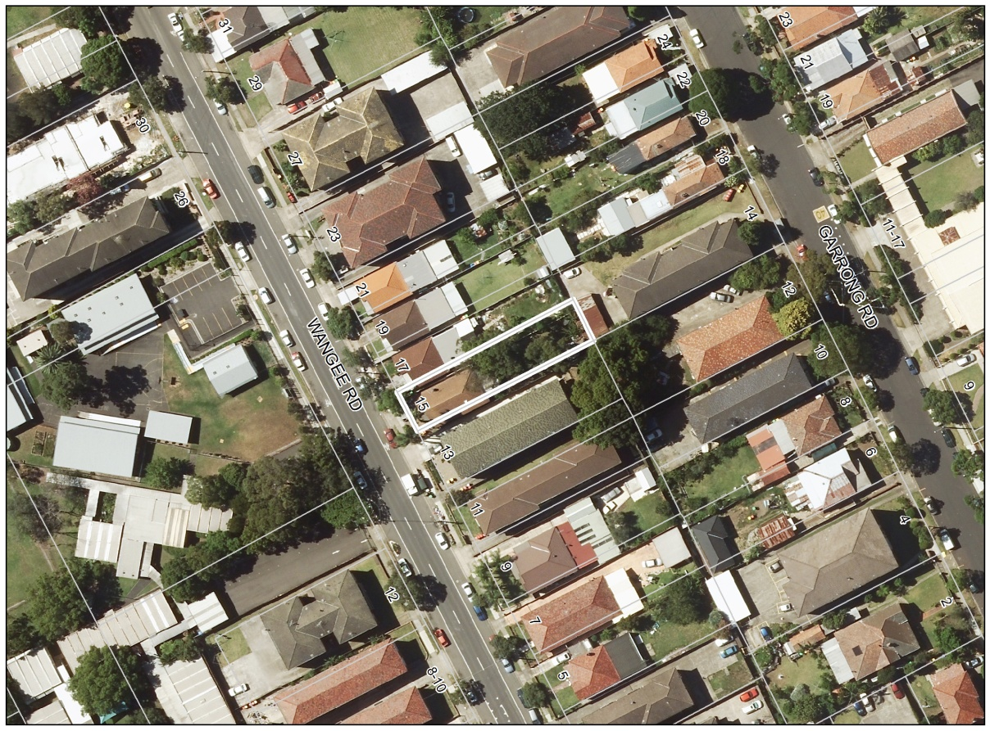

39 Ludgate Street, Roselands

This parcel of land at 39 Ludgate Street, Roselands is also shown on the Land Reservation Acquisition Map (Map 5), as Local Open Space. Council has recently completed acquisition of this land for public recreation purposes and as such it no longer needs to be shown on the Land Acquisition Map (Map 6).

The aerial photo showing locality of 39 Ludgate St, Roselands

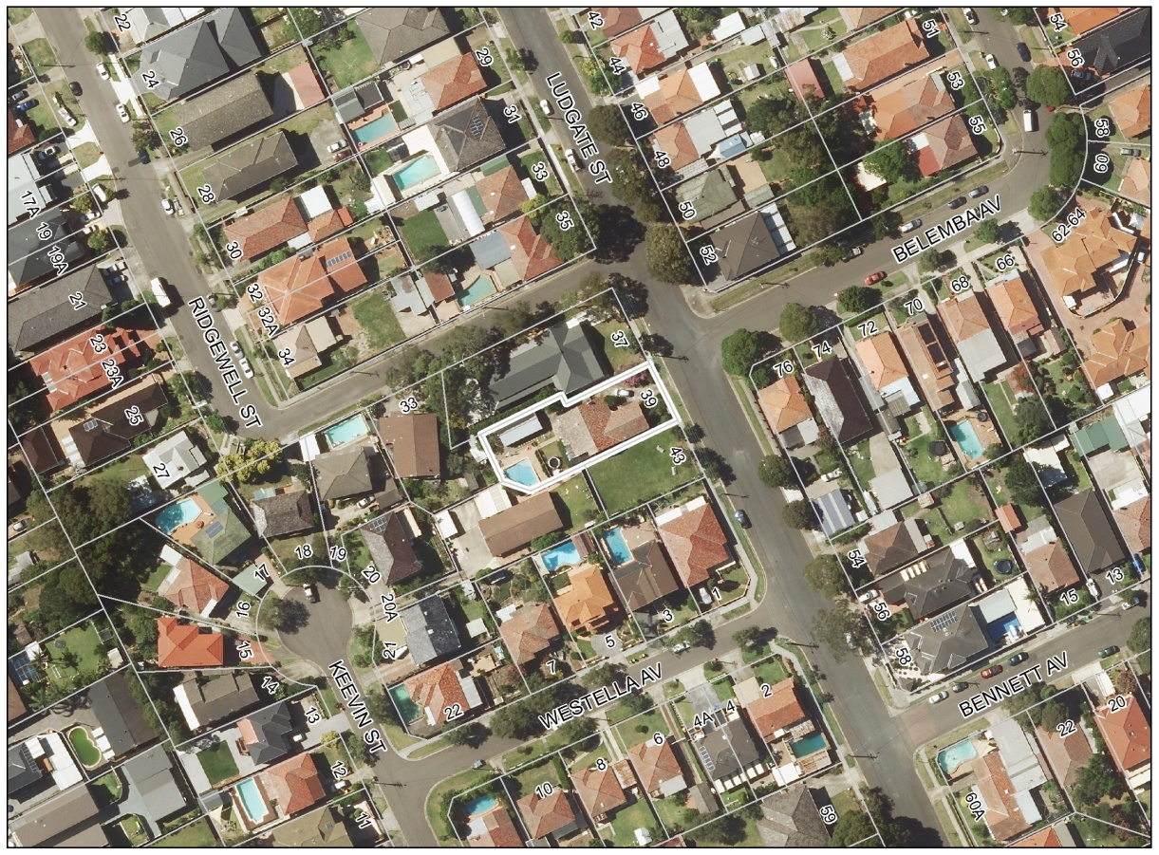

34 Allan Avenue, Belmore

This parcel of land at 34 Allan Avenue, Belmore due to a drafting error is not shown on the Land Reservation Acquisition Map (Map 7) as Local Open Space (RE1). Since Council is the responsible acquisition authority for this land, the Land Acquisition Map should be updated to reflect this (Map 8).

The aerial photo showing locality of 34 Allan Av, Belmore

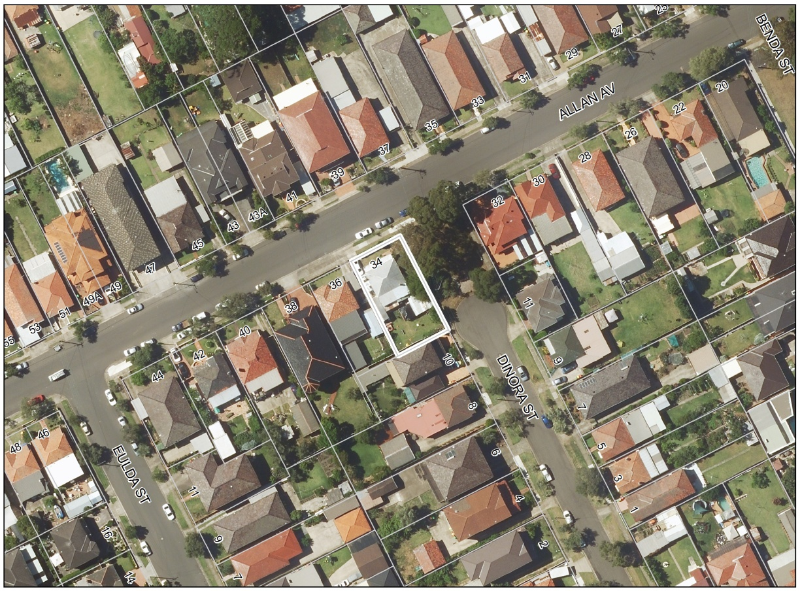

102-102A Rogers Street, Roselands

This mapping error shows two different zones for the site at 102–102A Rogers Street, Roselands (Lot 1 in DP 623244 and Lot B in DP 399441). The front section of the subject parcel of land is shown as being within in the R3 Medium Density Residential Zone (applicable to the road), while the remaining portion of land in the IN2 Light Industrial zone (Map 15).

This zoning error is also replicated on the Height of Building and Floor Space Ratio maps, which show an incorrect 8.5 metre height and 0.5:1 FSR respectively for the front section of the land (Maps 17 & 19).

The error came about as a result of the directive that roads are to be zoned in accordance with the Standard Instrument template. Prior to LEP 2012, this land was shown as unzoned as there was an earlier intention to carry out local road widening in this location (photograph 2). This is now not proposed to take place and it would therefore be appropriate to rectify these mapping anomalies. It is therefore recommended that the subject land be included within the Zone IN2 Light Industrial in their entirety to have a single zone (Map 16), and Height of Building Map (Map 18)and FSR Map adjusted accordingly (Map 20).

Photograph 2: Show the subject land, view from Rogers Street, Roselands

The aerial photo showing locality of 102-102A Rogers St, Roselands

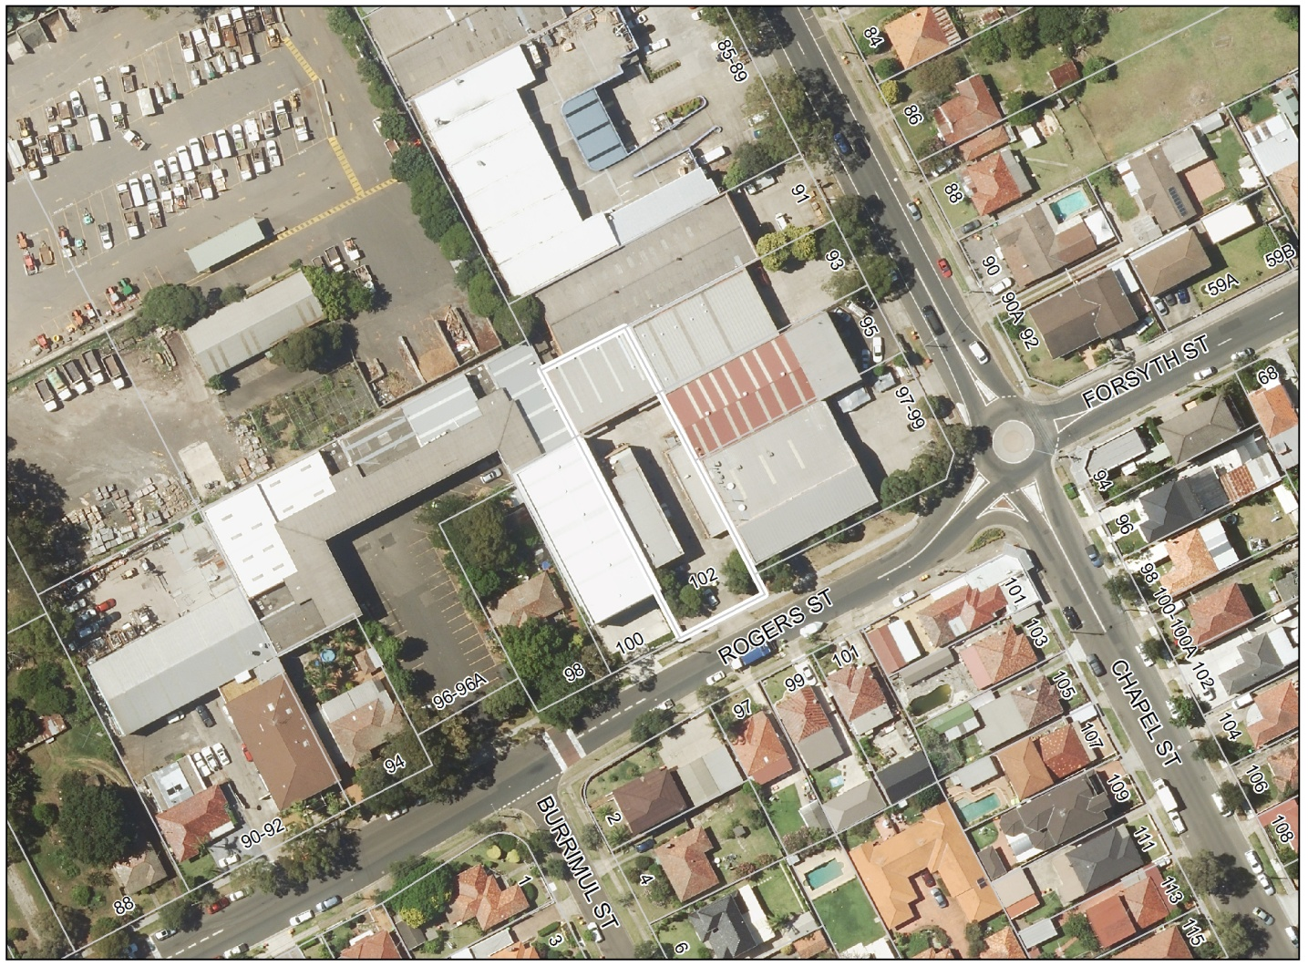

3 Sunbeam Street and 60 Charlotte Street, Campsie

The re-development of the former Sunbeam site, previously known as 60 Charlotte Street, Campsie, was approved under the former Part 3A of the Environmental Planning and Assessment Act. The zoning subsequently applied under CLEP 2012 was based on this Concept Plan approval. As development of the site has progressed, subsequent land subdivisions have given rise to a zoning mismatch between the initial LEP zone boundary and the actual final subdivision boundary within the site between the B1 Neighbourhood Centre zone and the R4 High Density Residential zone (Map 27).

It is proposed that the Land Zoning Map be amended to show the boundary between these two zones reflecting the final subdivision boundary as approved and constructed Map 28). Consequently, the Building Height Map and Floor Space Ratio Map need to be adjusted accordingly to the appropriate zoning boundaries (Maps 29, 30, 31 & 32).

The aerial photo showing locality of 3 Sunbeam St and 60 Charlotte St, Campsie

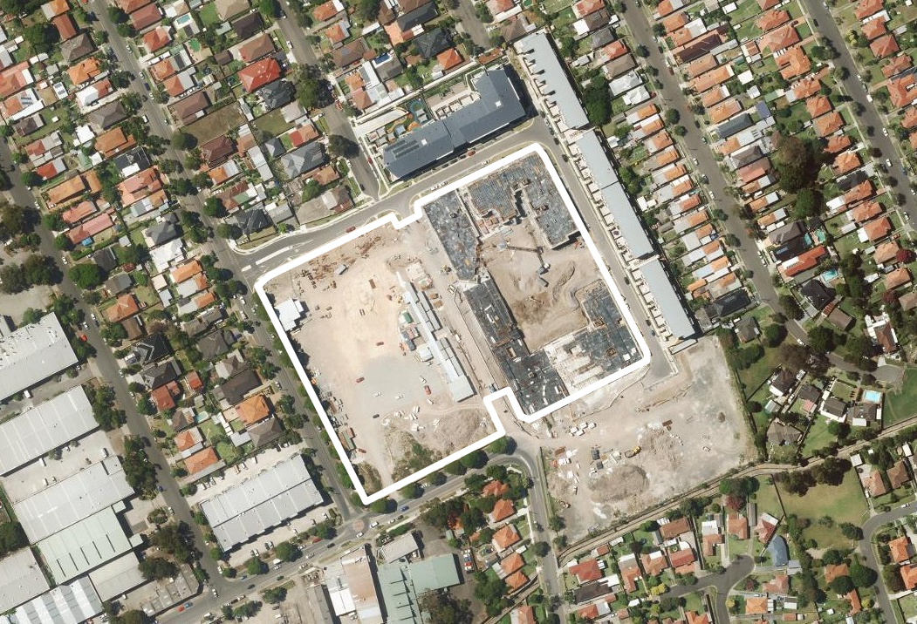

2 Objectives or Intended Outcomes

The objective of the Planning Proposal is to amend Canterbury LEP 2012 in order to rectify number minor mapping anomalies and/or drafting errors, make some minor corrections to the LEP text and the Heritage Register Schedule.

The intended outcomes of the Planning Proposal are as follows:

Amendments to the Planning Instrument:

- Add “Emergency Services Facility” as a permissible use in Zone RE1 Public Recreation.
- Remove the objective “To provide for residential uses, but only as part of mixed use development” from Zone B6 Enterprise Corridor.

Amendments to Schedule 5 - Environmental Heritage:

- Amend Item No. I 69 - from “Inter war urban park – Mary MacKillop Reserve” to read “Inter war urban park – Saint Mary MacKillop Reserve”.
- Amend Item No. I 82 – from “Canterbury Sugar Mill” to read “Canterbury Sugar Works”.
- Amend Item No. I 140 - from “Moorefields Methodist Cemetery” to read “Moorfields Methodist Cemetery”.

Amendments to LEP Maps:

- Amend the Land Reservation Map by removing the land reservation for 46 Fairmount Street, Lakemba.
- Amend the Land Reservation Map by removing land reservation for 15 Wangee Road, Lakemba.
- Amend the Land Reservation Map by removing land reservation for 39 Ludgate Street, Roselands.
- Amend the Land Reservation Map by adding land reservation for 34 Allan Avenue, Belmore.
- In relation to land at 102-102A Rogers Street, Roselands to amend the following Maps;
- Land Zoning Map to rectify error from two (2) zonings of IN2 and R3 into one (1) Zone IN2 Light Industrial,
- Height of Building Map to change from two (2) different height limit of 8.5 m and no height limit into no height limit for the whole site, as applicable to Zone IN2 Light Industrial,
- Floor Space Ratio Map to change from two (2) FSR of 1:1 and 05:1 into one (1) FSR of 1:1, as applicable to Zone IN2 Light Industrial.
- In relation to land at 3 Sunbeam Street and 60 Charlotte Street, Campsie to amend;
- Adjust zone boundary between R4 High Density Residential and B1 Neighbourhood Centre to reflect the final subdivision layout,
- Height of Building Map to adjust accordingly to the zoning boundaries,
- Floor Space Ratio Map to adjust accordingly to the zoning boundaries.

3 Explanations of Provisions – Proposed Amendments

The Planning Proposal seeks to amend Canterbury LEP 2012. Since the gazettal of the LEP, a number of corrections to LEP are required to address anomalies and drafting errors. These are:

- Amendments to the Planning Instrument – containing minor corrections relating to the LEP clauses,
- Amendments to Schedules – containing corrections to spelling for the Schedule of Heritage Items,
- Mapping Amendments – containing minor amendments to Land Reservation Map, Land Zoning Map, Height of Building Map and Floor Space Ratio Map in order to rectify mapping anomalies or eliminate mismatch and drafting errors.

These amendments are listed in Part 2 (objectives) and as per the tables below. Table 2 provides details of proposed amendments to the Planning Instrument. Table 3 lists items that require amendments to Schedule 5 – Environmental Heritage. Tables 4A, 4B, 4C and 4D are showing existing situation and proposed changes to LEP Maps in order to rectify anomalies and errors. Maps are shown in Attachment 6.

- Amendments to Planning Instrument as per table 2.

Table 2 – Amendments to Planning Instrument
Zoning (Canterbury LEP 2012) | Proposed LEP amendment
Zone RE1 Public Recreation | Add - Emergency Services Facility
Zone B6 Enterprise Corridor | Remove objective - To provide for residential uses, but only as part of mixed use development

- Amendments to Heritage Schedule as per table 3

Table 3 - Amendments to Schedules 5 – Environmental Heritage
Item No. | Current (Canterbury LEP 2012) | Proposed LEP amendment
Item No. I 69 | Inter war urban park – Mary MacKillop Reserve | Inter war urban park – Saint Mary MacKillop Reserve
Item No. I 82 | Canterbury Sugar Mill | Canterbury Sugar Works
Item No. I 140 | Moorefields Methodist Cemetery | Moorfields Methodist Cemetery

- Amendments to LEP Maps as per tables 4A, 4B, 4C and 4D

Table 4A – Land Reservation Acquisition Map Changes
LRA Map Title No | Address | Current (Canterbury LEP 2012) | Proposed LEP amendment
LRA_004 | 46 Fairmount Street, Lakemba | RE1 Local Open Space | No reservation
LRA_004 | 15 Wangee Road, Lakemba | RE1 Local Open Space | No reservation
LRA_004 | 39 Ludgate Street, Roselands | RE1 Local Open Space | No reservation
LRA_004 | 34 Allan Avenue, Belmore | No reservation | RE1 Local Open Space

Table 4B – Zoning Map Changes
LZN Map Title No | Address | Current (Canterbury LEP 2012) | Proposed LEP amendment
LZN_007 | 3 Sunbeam Street, Campsie | R4 High Density Residential  and B1 Neighbourhood Centre | R4 High Density Residential (boundary adjustment)
LZN_007 | 60 Charlotte Street, Campsie | B1 Neighbourhood Centre | B1 Neighbourhood Centre (boundary adjustment)

Table 4C – HOB Map Changes
HOB Map Title No | Address | Current (Canterbury LEP 2012) | Proposed LEP amendment
HOB_004 | 102-102A Rogers Street, Roselands | I 8.5 (8.5m) and no control | No control
HOB_007 | 3 Sunbeam Street, Campsie | L2 11.5 (11.5) and  K10 (10m) | L2 11.5 (11.5m) – boundary adjustment
HOB_007 | 60 Charlotte Street, Campsie | K 10 (10m) | K 10 (10m) – boundary adjustment

Table 4D – FSR Map Changes
FSR Map Title No | Address | Current (Canterbury LEP 2012) | Proposed LEP amendment
FSR_004 | 102-102A Rogers Street, Roselands | N 1 (1:1) and D 0.5 (0.5:1) | N 1 (1:1)
FSR_007 | 3 Sunbeam Street, Campsie | L 0.9 (0.9:1) and  No controls | L 0.9 (0.9:1) – boundary adjustment
FSR_007 | 60 Charlotte Street, Campsie | No controls | No controls – boundary adjustment

4 Justification

SECTION A: Need for the Planning Proposal

1. Is the planning proposal the result of any strategic study or report?

No. The Planning Proposal relates to the correction of a number of minor mapping anomalies and/or drafting errors, some inconsequential corrections and updates to the LEP text and the Heritage Register Schedule.

2. Is the Planning Proposal the best means of achieving the objectives or intended outcomes or is there a better way?

Yes. Amending Canterbury LEP 2012 through a Planning Proposal is the only way to make these amendments.

3. Is there a net Community benefit?

Yes. The Planning Proposal will correct a number of errors and anomalies as well as removing ambiguity.

SECTION B: Relationship to strategic planning framework

- Is the planning proposal consistent with the objectives and actions contained within the applicable regional or sub-regional strategy (including the Sydney Metropolitan Strategy and exhibited draft strategies?

The Strategic planning context for consideration of this Planning Proposal is A Plan for Growing Sydney (December 2014). The Government’s vision for Sydney is: a strong global city and a great place to live.

To achieve this vision, the Government has set down four (4) key goals that Sydney will be:
- a competitive economy with world class services and transport,
- a city of housing choice with homes that meet our needs and lifestyles,
- a great place to live with communities that are strong, healthy and well connected, and
- a sustainable and resilient city that protects the natural environment and has a balanced approach to the use of land and resources.

The Planning Proposal is considered to be consistent with the goals and directions of this plan. The compliance of the Planning Proposal in this respect is set out in the Table 5 below.

Table 5: Consistency with A Plan for Growing Sydney

Provision | Comment
Goal 2: Sydney’s housing choices  Direction 2.1: Accelerate housing supply across Sydney  Direction 2.2: Accelerate urban renewal across Sydney  Direction 2.3: Improve housing choice  Direction 2.4 Deliver timely and well planned greenfield precincts and housing | Not applicable. This Planning Proposal will not adversely impact on the directions and actions identified in the plan to provide more housing with greater choice of dwelling types in well serviced locations.  Not applicable.  Not applicable.  Not applicable.
Goal 3: Sydney’s great places to live | Not applicable. The planning proposal is only dealing with relatively minor matters.
Goal 4: Sydney’s sustainable and resilient environment | Not applicable. The Planning Proposal is only dealing with relatively minor matters.
South subregion priorities | This section of the plan does not contain any specific priorities that are relevant to the Planning Proposal.

- Is the Planning Proposal consistent with the local Council’s community strategic plan, or other local strategic plan?

5.1 Residential Development Strategy

Not relevant. The amendments being sought will have no direct impact on housing targets.

5.2 City of Canterbury Community Strategic Plan 2014-2023

Council’s Community Strategic Plan 2014-2023 (Community Plan) which was adopted in February 2014 sets the vision for the Canterbury LGA into the next decade and aims to promote sustainable living. The Community Plan sets out long term goals under five key themes being:

- Attractive city;
- Stronger community;
- Healthy environment;
- Strategic leadership; and
- Improving Council

The Planning Proposal is generally consistent with Council’s Community Strategic Plan. It helps to achieve the objective of ‘Attractive City’ through the rectifying anomalies, corrections of errors and boundaries adjustment to achieve a ‘Balanced Urban Development’ through the more appropriate controls. The Planning Proposal is also consistent with Council strategies, which include aim of supporting the renewal of existing local town centres.

- Is the planning proposal consistent with applicable State Environmental Planning Policies?
Yes. See Appendix 2.

- Is the planning proposal consistent with applicable Ministerial Directions (s117 directions)?
Yes. See Appendix 3.
SECTION C: Environmental, social and economic impact

- Is there any likelihood that critical habitat or threatened species, populations or ecological communities, or their habitats, will be adversely affected as a result of the proposal?

No. There is no likelihood that critical habitat or threatened species, populations or ecological communities, or their habitats, will be adversely affected as a result of the Planning Proposal. The Planning Proposal pertains to land which is currently within a fully urbanised environment.

- Are there any other likely environmental effects as a result of the planning proposal and how are they proposed to be managed?

The Planning Proposal relates to urban land that will generally be within the same urban use. Any subsequent development application will be subject to merit assessment under the provisions of CLEP 2012 and CDCP and other applicable Planning Instruments. The key considerations arising from the Planning Proposal are described below:

Building form
The Planning Proposal is intending only amendments to minor matters. It does not propose to amend any land use pattern. It is anticipated that the proposed minor boundary adjustments or rectifying zoning where there is currently a non-conforming use in the zone will not directly affect building form or housing stock.

Flooding
Not applicable. The Planning Proposal is only dealing with relatively minor matters

Site contamination
Not applicable. The Planning Proposal is only dealing with relatively minor matters

Traffic and Parking
Not applicable. The Planning Proposal is only dealing with relatively minor matters

Cycle and pedestrian movement
Not applicable. The Planning Proposal is only dealing with relatively minor matters

- How has the planning proposal adequately addressed any social and economic effects?
The purpose of the Planning Proposal will reinforce council planning policies and planning controls. This will improve the operation of the CLEP 2012 and provide positive social and economic outcomes for the whole community.

SECTION D: State and Commonwealth interests
- Is there adequate public infrastructure for the planning proposal?

Yes. These sites are adequately serviced by infrastructure services that are generally available within the urban environment such as; reticulated water, drainage, sewerage, electricity and telephone. The planning proposal does not generate any apparent need to upgrade or improve public infrastructure. Consultation with key service providers can occur as part of the planning proposal exhibition process.

- What are the views of the State and Commonwealth public authorities consulted in accordance with the gateway determination?

Consultation with any State and Commonwealth public authorities has not yet been undertaken. Council will engage in such consultation with any such public authority in accordance with the Gateway Determination.
5 Mapping

The following maps (Appendix 6) have been prepared to support the planning proposal:
- Existing land reservation, zoning, height of building and floor space ratio Map.
- Proposed land reservation, zoning, height of building and floor space ratio Map.

6 Community Consultation

The following community consultation will occur should the planning proposal receive a Gateway Determination:

- Notification in the Canterbury Council column which appears in local newspapers.
- Notification letters to any relevant State Agencies or authorities nominated by the Department.
- Notification letters sent to directly affected, adjoining and nearby property owners.
- Advertising of the proposal on Council’s website and at Council’s Administration Building.

It is proposed to have a 28 day exhibition period to enable adequate time for consultation to take place.

7 Project Timeline

This is outlined in the table 6 below:

Table 6: Project timeline

Planning proposal stage | Timeframe
Gateway determination | January 2016
Government Agency Consultation | July 2017
Public exhibition period | July 2017
RPA Assessment of Planning Proposal and Exhibition outcomes | August 2017
RPA Decision to make the LEP Amendment (if delegated) | September 2017
Submission of endorsed LEP to DP&E for finalisation | October 2017
Forwarding of LEP Amendment to DP&E for Notification  (if delegated) | October 2017

ATTACHMENTS
1 Information Checklist
2 State Environmental Planning Policies
3 Section 117 Directions
4 Evaluation Criteria for the Delegation of Plan Making Functions
5 Delegated plan making reporting template
6 Maps
7 Council Resolution 12 November 2015

