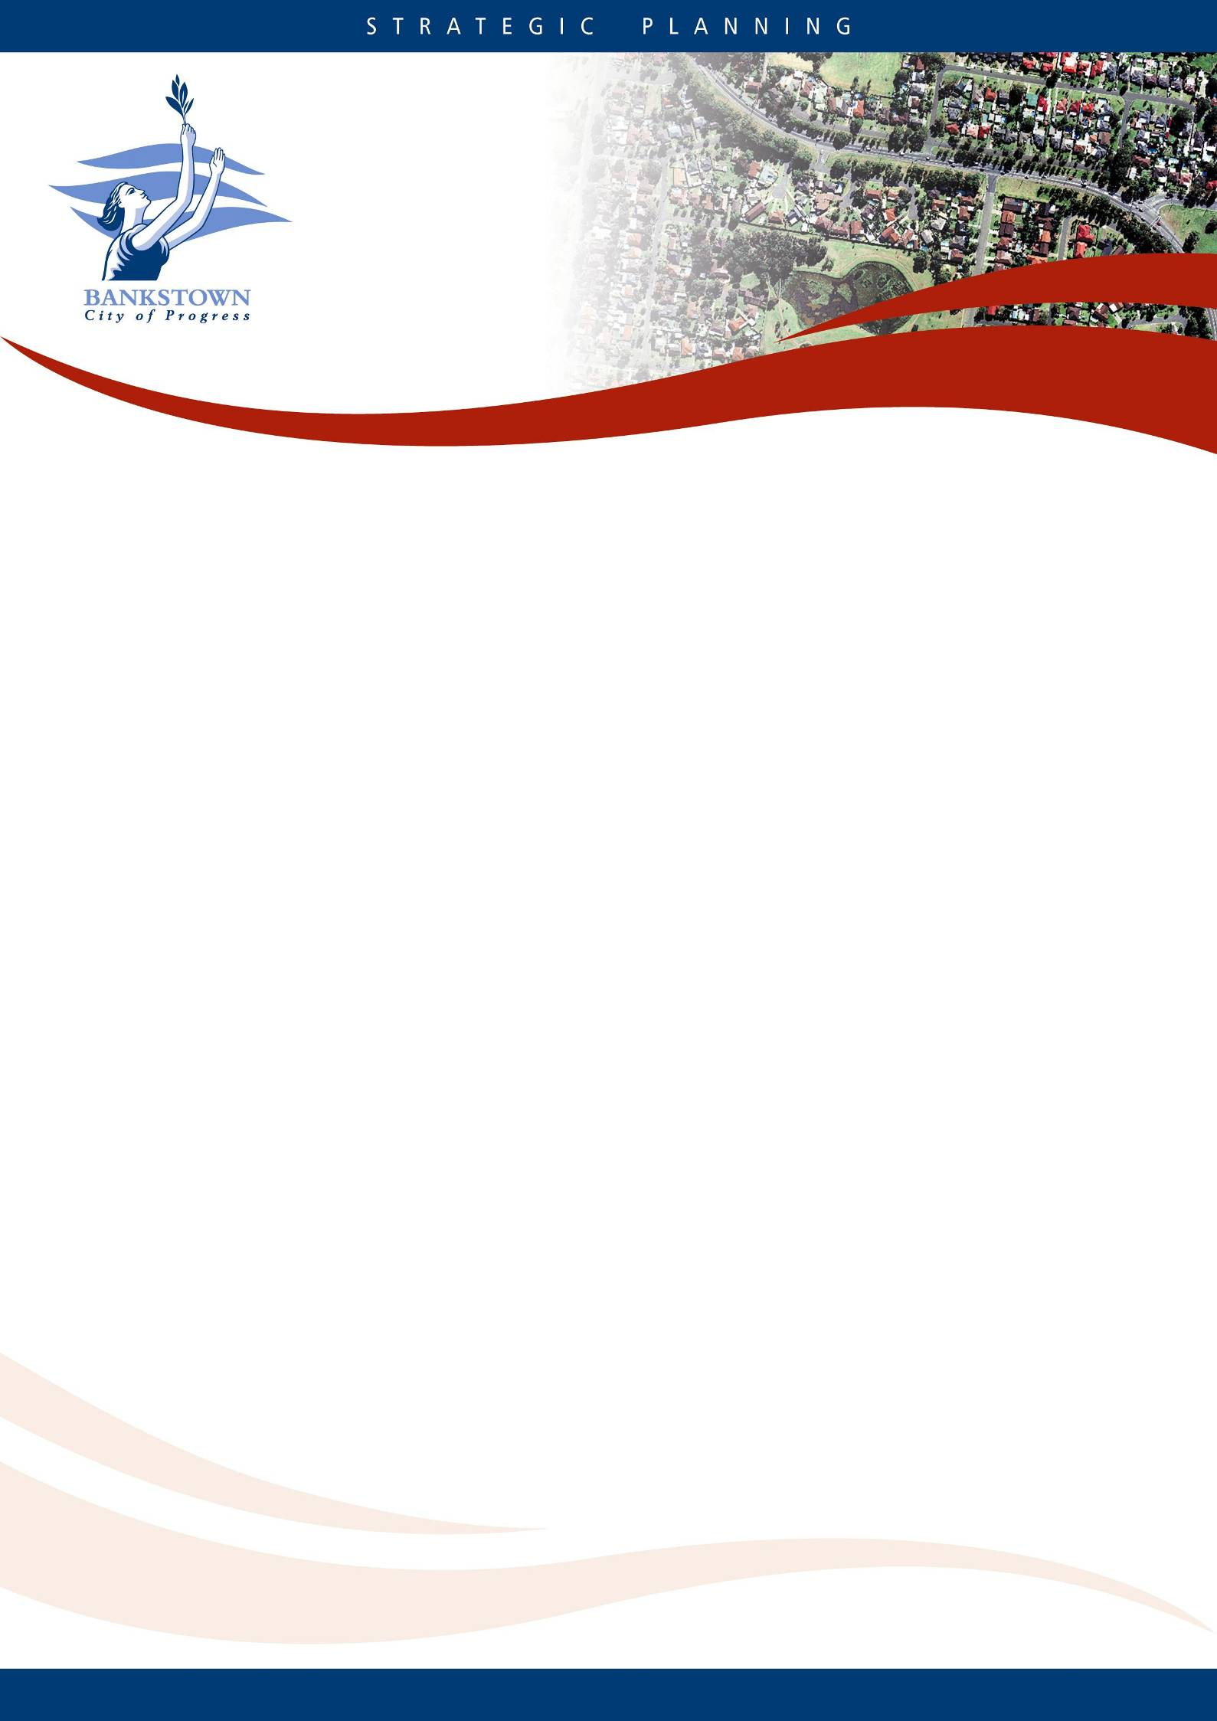
DRAFT
PART B11

TREE PRESERVATION
ORDER
Bankstown
Development Control
Plan 2015

CONTENTS

Section 1 Introduction 3

Section 2 Tree Management 4

Section 3 Definitions 9

SECTION 1–INTRODUCTION

Trees are a vital component of the urban environment of the City of Bankstown. They provide essential ecological, environmental, social, health, heritage and amenity values, all contributing to make the City of Bankstown a pleasant place to live and work. As well as these direct values to residents, urban trees also have equally important values in their own right in maintaining and enhancing biodiversity and natural ecosystems and processes.

The entirety of the trees and large woody shrubs that grow on all public and private land form Bankstown’s Urban Forest.

Council has a vision for a clean, green, healthy and bio-diverse natural environment. A canopy of trees that shelter and beautify the City of Bankstown is an integral component of that vision.

Part B11 of the Bankstown Development Control Plan 2015 contains the controls for tree management in the City of Bankstown. Part B11 is made pursuant to clause 5.9(2) of the Bankstown Local Environmental Plan 2015 and applies to all land in the City of Bankstown.

Objectives

The objectives of Part B11 of this DCP are:

- To sustainably manage the tree resources to improve the visual, physical and environmental amenity of the City of Bankstown.

- To promote the use of professional standards and best practices in tree management.

- To list the controls for the pruning, removal and replacement planting of trees in the City of Bankstown.

SECTION 2-TREE MANAGEMENT

Introduction

This section provides the controls for the pruning, removal and replacement planting of trees in the City of Bankstown.

Development Controls

The development controls to achieve the objectives are:

Works Requiring Consent

2.1 A person must not ringbark, cut down, top, lop, prune, remove, injure or wilfully destroy any prescribed tree defined in clause 2.3 or carry out excavation and earthworks within the tree protection zone except with the approval of Council and in accordance with any conditions imposed with this approval.

2.2 Development consent is required to remove any tree;

located on a property listed as a heritage item in Schedule 5 of Bankstown Local Environmental Plan 2015; or

located on biodiversity lands listed on the Biodiversity Protection Map under the Bankstown Local Environmental Plan 2015.

Prescribed Trees

  - Part B11 applies to:

- All trees that are 5.0 metres or more in height; and

- All mangroves, regardless of size; and

- All trees, regardless of size, listed as Vulnerable or Endangered or a component of an Endangered Ecological Community listed under the Threatened Species Conservation Act 1995; and

- All trees, regardless of size, listed under the Environmental Protection and Biodiversity Conservation Act 1999; and

- All trees, regardless of size, located on properties listed as a heritage item in Schedule 5 of Bankstown Local Environmental Plan 2015; and

- All trees, regardless of size, located on biodiversity lands listed on the Biodiversity Protection Map under Bankstown Local Environmental Plan 2015; and

- All trees, regardless of size, located in the foreshore area under the Bankstown Local Environmental Plan 2015.

Exempt Works

  - Despite clause 2.3, Part B11 does not apply to:

- Trees located within 3.0 metres of the external wall of an approved dwelling, not including a secondary dwelling. The distance shall be measured from the external wall of the approved dwelling to the centre of the trunk of the tree at 1.4 metres above ground level.

- The following tree species:

Scientific Name | Common Name
Acacia baileyana | Cootamundra Wattle
Acacia podalyriifolia | Queensland Silver Wattle
Acacia saligna | Golden Wattle
Ailanthus altissima | Tree of Heaven
Bambusa spp. | Bamboo
Celtis sinensis | Hackberry
Cinnamomum camphora | Camphor Laurel (less than 10 metres in height)
Citrus limon cvs. | Lemon Tree
Citrus reticulata cvs. | Mandarin Tree
Citrus sinensis cvs | Orange Tree
Citrus x paradisi cvs | Grapefruit Tree
Eriobotrya japonica | Loquat Tree
Erythrina x sykseii | Common Coral Tree
Eucalyptus nicholii | Narrow-leafed Peppermint
Eucalyptus scoparia | Willow Gum
Ficus elastica and cvs. | Rubber Tree
Gleditsia triacanthos | Honey Locust
Ligustrum lucidum | Broad-leaf Privet
Ligustrum sinense | Narrow-leaf Privet
Liquidambar styraciflua | Liquidambar
Malus domestica and cvs. | Apple Tree
Mangifera indica | Mango Tree
Morus spp. | Mulberry Tree
Musa spp. | Banana
Olea europaea subspecies africana | African Olive
Phoenix canariensis | Canary Island Date Palm (with a trunk less than 4 metres in height)
Phyllostachys spp. | Rhizomatous Bamboo
Pinus spp. | Pine Trees
Populus spp. | Poplars
Prunus avium / P. cerasus and cvs. | Cherry Tree
Prunus persica and cvs. | Peach Tree
Prunus spp. and cvs. | Plum Tree
Prunus spp. and cvs. | Apricot Tree
Pyrus communis and cvs. | European Pear
Robinia pseudoacacia and cvs | Robinia
Salix spp. | Willow Tree
Schefflera actinophylla | Umbrella Tree
Schinus terebinthifolius | Broad-leaf Pepper Tree
Syagrus romanzoffiana | Cocos Palm
Toxicodendron succedaneum | Rhus Tree
X Cupressocyparis leylandii and cvs. | Leyland Cypress

Plants declared a Noxious Weed under the Noxious Weeds Act 1993;

- Dead trees where they are not required as habitat for native fauna;

- Dangerous trees where it can be proved by the owner to Council’s satisfaction that pruning or removal is the only reasonable option to avoid an imminent threat to human life or property.

- Recognised horticultural varieties of trees grown for fruit production;

- Selective pruning of up to a total of 10% of the crown of an indigenous tree and up to a total of 20% of the crown of an exotic tree species over a 12 month period. Branches pruned must be no greater than 150 mm in diameter. Pruning works must comply with Australian Standard AS 4373-2007 Pruning of amenity trees, and consist of the following pruning classes only:

Crown Maintenance:
- Deadwooding
- Crown thinning
- Selective pruning

Crown Modification:
- Reduction pruning
- Crown lifting
- Remedial pruning
- Line clearance

NOTE: Clause 2.4 (g) does not apply to any tree:
- listed as Vulnerable or Endangered or a component of an Endangered Ecological Community listed under the Threatened Species Conservation Act 1995; or
- listed under the Environmental Protection and Biodiversity Conservation Act 1999; or
- located on a property listed as a heritage item in Schedule 5 of Bankstown Local Environmental Plan 2015; or
- located on biodiversity lands listed on the Biodiversity Protection Map under Bankstown Local Environmental Plan 2015; or
- located in a Conservation Corridor; or
- located in the foreshore area under Bankstown Local Environmental Plan 2015.

- Pruning of palms to remove fruit and dead fronds;

- Trees listed for removal under a current Development Consent.

- Tree works lawfully conducted in accordance with the Forestry Act 1916, Telecommunications Act 1997, the Airports Act 1996, the Roads Act 1993, the Rural Fires Act 1997, the Electricity Supply Act 1995, the State Emergency and Rescue Management Act 1989, the Surveying and Spatial Information Act 2002, and an Order issued under the Tree (Disputes between Neighbours) Act 2006.

Matters for Consideration

  - Council will consider – but not be limited to – the following matters when determining an application to prune or remove a tree:

- the suitability of the tree for site conditions;

- the condition of the tree;

- the contribution of the tree to the local landscape;

- the environmental contribution of the tree;

- the impact of the tree on the property and associated infrastructure;

- the amenity of the occupants of the property;

NOTE: The dropping of leaves, flowers, fruits, seeds or small elements of deadwood are part of a trees normal life cycle, and ordinarily will not provide the basis for the pruning or removal of the tree.

Approval granted by Council

  - A permit granted by Council is valid for a period of 12 months from the date of issue.

  - The permit must be issued to the owner of the property on which the tree is located.

  - A copy of the permit must be on site during the course of the works, and must be produced by the person undertaking the work on demand by a Council Officer.

  - A permit granted by Council or development consent may be subject to the requirement to plant suitable replacement trees on the property, offset tree planting, or any other conditions deemed suitable by Council. The replacement planting shall be completed within 28 days of the tree removal works, or as otherwise specified by Council.

Refusal

  - Council may refuse in full or in part an application made under Part B11.

Appeals

An applicant may appeal Councils decision if they believe:

- Council has erred in its judgement, or

- Councils decision is harsh or unreasonable, or

- Additional information has become available subsequent to the inspection by Council.

An appeal must be lodged within three months of the date of Councils determination. Council may require the appellant to provide reports or other suitable documentation from appropriately qualified consultants or experts relevant to the basis of the appeal.

Penalties

2.12 A person(s) who contravenes or causes or permits this Part B11 to be contravened shall be guilty of an offence and liable for prosecution.

A person found guilty of contravening or causing or permitting the contravention of this Plan shall be liable for a fine of up to 10,000 Penalty Units or as increased from time to time.

In addition to a fine, the Court may also require the person to replace the damaged or destroyed tree/s and maintain such tree/s until maturity.

SECTION 3-DEFINITIONS

Approved Dwelling: For the purposes of Part B11, an approved dwelling means a dwelling with development consent or complying development consent under the Environmental Planning and Assessment Act 1979 to the satisfaction of Council.

Arborist: A person with training to AQF Level 3 in Arboriculture, or above, or equivalent recognized and relevant experience.

Australian Qualification Framework (AQF): A national framework for education and training in Australia.

Australian Standard® AS 4373-2007 Pruning of amenity trees: The standard that specifies methods of pruning and gives guidance on correct and uniform practices.
Australian Standard® AS 4970-2009 Protection of trees on development sites: The standard that specifies principles for protecting trees on land subject to development.
Consultant Arborist: A person with training to AQF Level 5 in Arboriculture, and/or equivalent experience.

Crown: The portion of the tree consisting of branches and leaves and any part of the trunk (or stem) from which branches arise.

Crown Lifting: The removal of lower branches.

Crown Thinning: Reducing the crown density of the tree by removing smaller branches and retaining the major structural branches.

Dead Tree: A tree that no longer has a functioning xylem and/or phloem system; evidenced by permanent leaf loss, permanent desiccation of branches and stems, and bark peeling off back to the sapwood.

Deadwood: Dead branches within the crown of a tree.

Deadwooding: The removal of dead branches

Dwelling: For the purposes of Part B11, means a room or suite of rooms occupied or used or so constructed or adapted as to be capable of being occupied as a separate domicile, but does not include permanent fixed structures such as deck, garages and similar structures that are attached to the building.

Exotic Tree: A tree species not originating from Australia.

Indigenous Tree: A tree species that existed in the State before European settlement.

Injury: Damage to the trunk, crown or root system of a tree or any other activity that is likely to compromise the health and/or structure of the tree, including trenching, excavating or soil level changes within the tree protection zone (TPZ) of the tree.

Line Clearance: Pruning to maintain safety clearances around overhead services. The minimum safety clearance for insulated cable with less than 100m span length is 0.5 metres. (Ref: ISSC 3 Guidelines for Managing Vegetation Near Power Lines, December 2005)

Lop: Cutting branches or stems between branch unions or internodes.

Prescribed Tree: A tree listed under clause 2.3 of Part B11.

Prune: The systematic removal of branches. Pruning is not lopping, topping, or the cutting back of branches flush with the stem or trunk.

Reduction Pruning: Reducing the length of a branch by pruning it back to an internal branch or stem.

Remedial Pruning: The removal of diseased, damaged or lopped branches back to undamaged or healthy tissue on trees that have already lost their nature structure due to disease, storm damage or other mechanical injury

Ringbark: A circumferential cut made around the trunk of a tree which removes a band of tissue to the depth of and including the cambium.

Secondary Dwelling: A self-contained dwelling that:
- is established in conjunction with another dwelling (the principal dwelling), and
- is on the same lot of land as the principal dwelling, and
- is located within, or is attached to, or is separate from, the principal dwelling.

Selective Pruning: Pruning or removing branches that are causing a specific problem.

Structural Root Zone (SRZ): Is the area required for tree stability. The SRZ is a radial distance measured from the trunk of the tree calculated in accordance with s.3 of Australian Standard AS 4970-2009 Protection of trees on development sites.

Top: Reducing the height of a tree by lopping the branches or stems.

Tree: For the purposes of this Plan, a tree is defined as a long lived perennial plant greater than 5 metres in height with one or relatively few main stems or trunks.

Tree Protection Zone (TPZ): Is the area above and below ground required for tree viability. The TPZ is a radial distance measured from the trunk of the tree calculated in accordance with s.3 of Australian Standard AS 4970-2009 Protection of trees on development sites.

Tree Works: are works affecting the form, structure or crown of a tree, including, but not limited to, root cutting, lopping, crown lifting, reduction pruning, selective pruning, crown thinning, remedial pruning and complete tree removal.

Urban Forest: The totality of trees and shrubs on all public and private land in and around urban areas (including bushland, parkland, gardens, and street trees) and is measured as a canopy cover percentage of the total area, and is recognised as a primary component of the urban ecosystem. (Local Government NSW Urban Forestry Policy)

