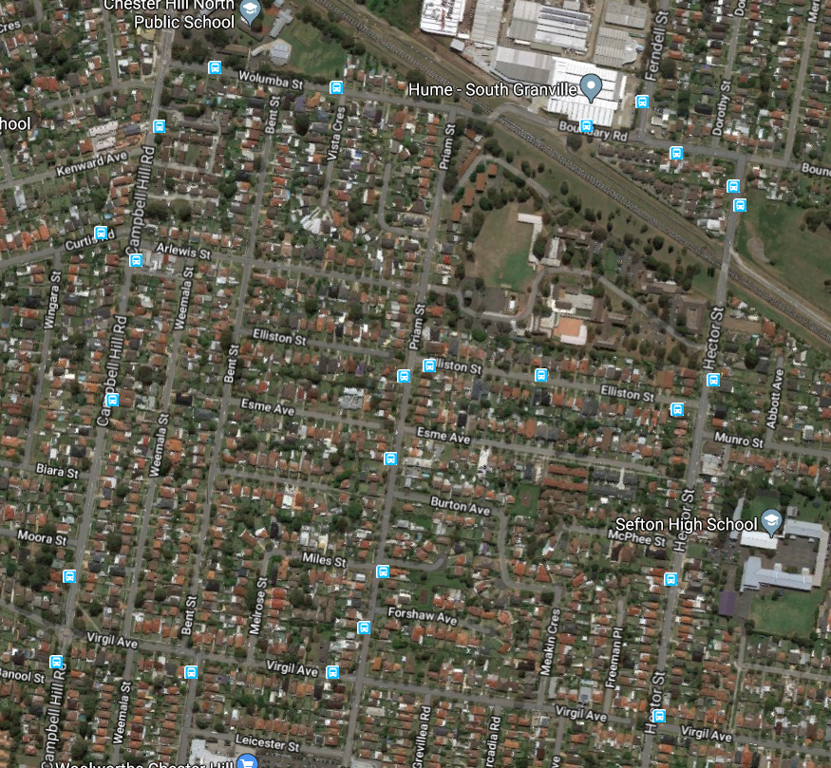

Hector Street Bridge

Wolumba Street Bridge

**Hector and Wolumba Street**

**Bridges**

**Upgrade and Renewal**