Patrick Allan "Pat" Rogan
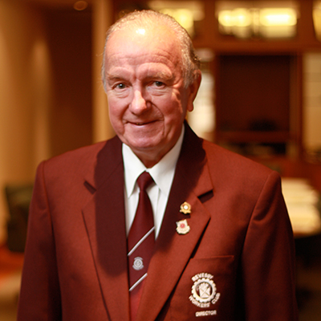
Patrick Allan "Pat" Rogan (22 September 1936 – 10 February 2015) was an Australian politician. He was the Labor Party member of the New South Wales Legislative Assembly for East Hills from 1973 to 1999.
Rogan was apprenticed in electrical trades and received higher education from Granville Technical College and Ultimo Technical College. He was a senior automation sales engineer, and also served in the Royal Australian Air Force for his National Service. He was also active in the Australian Labor Party, and was president of the electoral councils for both his federal seat of Banks and the state seat of East Hills
In 1973, the sitting member for East Hills, Joe Kelly, retired and Rogan was preselected as his replacement. He won the seat easily, and was never seriously challenged in subsequent elections. He never rose from the back bench and retired in 1999
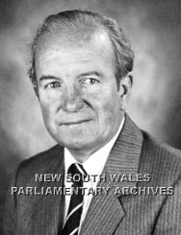
From 1973 to 1999, Pat served in State Parliament as a Member for East Hills. He made great achievements in this role including working on the Chelmsford Royal Commission, initiating the Salt Pan Creek walkway with Mayor Gordon Parker, the duplication of the railway to East Hills, initiating the Stacey Street overpass and securing funding for the widening and improvements to Davies Road.
Following his success in Parliament, in 1999, Pat retired from MP for East Hills and in that same year he became Chairman of ClubsNSW. As Chairman of ClubsNSW, Pat oversaw the introduction of an industry Code of Practice and best practice guidelines to improve accountability and better inform Club Directors about their legal responsibilities, government legislation and duty of care. Significantly, Pat Rogan also became the public face for the anger over the club gaming tax in 2003 that would force clubs to pay $1.8 billion in taxes over the next seven years.
On 17 February 2015, Patrick Rogan was farewelled as a significant member of the community who played a vital role in public matters and the success of clubs in NSW. Pat Rogan was driven to improve areas throughout the local community. He was dedicated to many initiatives and held various positions that paved the way for good change.
In an inaugural speech, Alan Ashston stated his appreciation for the work that Pat had completed in the community; “Pat’s dedication and commitment to our local community exemplifies the spirit of public service that should be the most important aspect of any citizen’s desire to seek election to Parliament.”
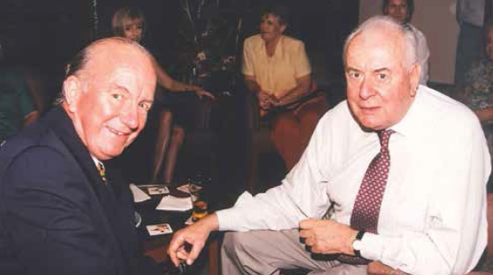
Pat Rogan was a hardworking politician who went about his commitments with a gentlemanly manner. He made every effort to serve the community well and fought for all injustice.

https://en.wikipedia.org/wiki/Pat_Rogan/span
https://en.wikipedia.org/wiki/Pat_Rogan/span
https://en.wikipedia.org/wiki/Pat_Rogan/span

